# TASTY FOODS

INTERNSHIP PROJECT REPORT

***by***

## M . PRAVALLIKA

**22KQ1A04E4**

**N . LUDHYAMMA**

**22KQ1A04E5**

Department of **ECE**

PACE INSTITUTE OF TECHNOLOGY AND SCIENCES

Ongole

June,2024

**APPENDIX 1**

## BONAFIDE CERTIFICATE

This is to certify that this project report entitled **“TASTY FOODS”** submitted to **PACE Institute of Technology and Sciences**,is a bonafide record of work done by

**“Pravallika , Ludhyamma”** under my supervisionfrom **20-MAY-2024** to **12-JUNE-2024**

Signature

Mr. Kasireddy Ramakumar

Place : Ongole

Date : 10/06/2024

APPENDIX 2

## Declaration by Author(s)

This is to declare that this report has been written by me/us. No part of the report is plagiarized from other sources. All information included from other sources have been duly acknowledged. I/We aver that if any part of the report is found to be plagiarized, I/we are shall take full responsibility for it.

**M.PRAVALLIKA**

**22KQ1A04E4**

**N.LUDHIYA**

**22KQ1A04E5**

Place : Ongole

Date : 10/06/2024

### APPENDIX 3

### TABLE OF CONTENTS

**CHAPTER NO. TITLE PAGE NO.**

1. **Introduction .......................................................................... 1**
2. **Abstract ................................................................................. 2**
3. **Methodology .......................................................................... 3**
4. **Result ...................................................................................... 4**
5. **Conclusion .............................................................................. 5**
6. **Future Work ........................................................................... 7**

# 1.Introduction

**Welcome to Our Tasty World!**

Hello and welcome to our restaurant website! We're excited to have you here. Our website is like a special menu book where you can explore all the delicious food we make. Whether you're craving savory dishes, sweet treats, or something in between, you'll find it all right here.

**What You'll Find on Our Website:**

1. **Delicious Food Pictures:** Get ready to drool over big, beautiful pictures of our mouthwatering dishes. Just looking at them will make your tummy rumble!
2. **Easy Online Ordering:** Hungry and in a hurry? No problem! You can order your favorite meals online and pick them up whenever you're ready. It's quick, easy, and oh-so-convenient.
3. **Special Events and Offers:** We love celebrating with our customers! Keep an eye out for special events, like holiday parties and live music nights, as well as tasty deals and discounts.
4. **Meet Our Team:** Behind every tasty dish is a talented chef. Learn more about the people who make our food so delicious and discover their favorite recipes.

**How to Use Our Website:**

* Just click around! Our website is super easy to use. You can explore our menu, place orders, and find all the information you need to plan your visit.

**Why We're Here:**

We created this website because we love sharing our passion for good food with you. Whether you're a regular customer or just discovering us for the first time, we want to make your experience with us as tasty and enjoyable as possible.

So go ahead, take a look around, and start planning your next delicious meal with us. We can't wait to see you at our restaurant!

# 2.ABSTRACT

**Discover Delicious Dining at Our Restaurant :**

Welcome to our restaurant's online home! Our website is your gateway to a world of tasty treats and unforgettable dining experiences. With mouthwatering pictures, easy online ordering, and exciting events, there's something for everyone to enjoy.

**What You'll Find:**

* **Tempting Food Photos:** Feast your eyes on our delectable dishes, beautifully captured to make your taste buds dance with anticipation.
* **Convenient Ordering:** Skip the line and order your favorite meals online for quick pickup or delivery, making mealtime a breeze.
* **Exciting Events:** Join us for special events and promotions, from themed nights to exclusive deals, for an extra dose of fun and flavor.
* **Meet Our Team:** Get to know the talented chefs and friendly staff behind the magic, sharing their passion for good food with every dish they create.

**Why It Matters:**

Our website is more than just a place to browse menus; it's a digital extension of our commitment to serving delicious food and creating memorable moments for our guests. Whether you're a loyal patron or a first-time visitor, we're here to make your dining experience as delightful and convenient as possible.

**Join Us Online:**

So why wait? Come explore our website, place your order, and let us take you on a culinary journey you won't soon forget. We can't wait to welcome you to our table and share our love for great food with you!

**3.METHODOLOGY**

**Building Your Tasty Website**

1. **Plan Your Menu:** Decide what dishes you want to showcase on your website. Take mouthwatering photos of your best dishes.

2.**Choose Your Tools:** Pick an easy-to-use website builder like Wix or WordPress. These tools make it simple to create and update your site.

**3. Design Your Layout:** Choose a clean and inviting design for your website. Make sure it's easy for visitors to find what they're looking for, like your menu and contact information.

**4. Write Your Content:** Write clear and engaging content for your website. Tell visitors about your restaurant's story, your chef, and what makes your food special.

**5. Add Online Ordering:** If you offer delivery or takeout, add an online ordering system to your website. This makes it easy for customers to place orders from their computer or phone.

**6 . Promote Your Website:** Spread the word about your new website! Share it on social media, put it on your menus, and encourage customers to visit.

1. **Monitor and Update:** Keep an eye on your website's performance. Use tools like Google Analytics to see how many people are visiting and what they're looking at. Update your site regularly with new menu items and promotions.

**8. Listen to Feedback:** Pay attention to what your customers are saying. If they have suggestions for how to improve your website, take them into consideration.

**4.RESULT**

**What We Do:**

* We show you what yummy food we have.
* You can book a table or order food to take away.
* We want you to know about special events and deals.
* You can see pictures of our restaurant inside.
* We like hearing what you think about our food.

**How Our Website Looks:**

* It's simple and nice to look at.
* You can see big pictures of our food.
* It's easy to click and find what you want.
* You can use it on your phone or computer.

**How We Made It:**

* We built it ourselves using simple tools.
* We made sure it works well on all devices.

**Why You Should Visit Us:**

* You can see what delicious food we have.
* You can book a table or order food easily.
* You can find out about our special events and offers.
* You can tell us what you think about our food.

**Come Visit Us Online and Enjoy Our Tasty Treats!**

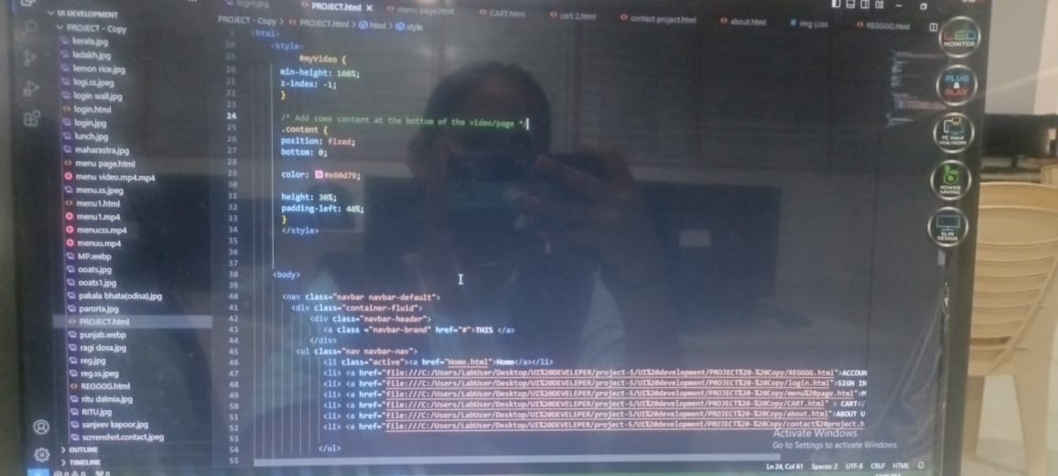



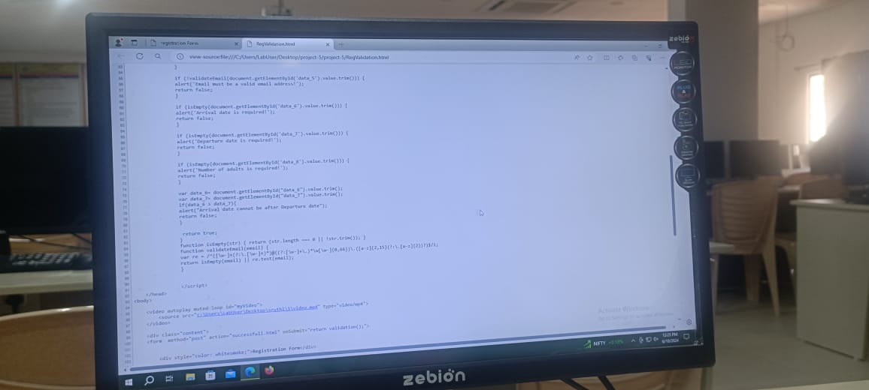



**CODE**

**SCREENSHOT(HOME PAGE)**



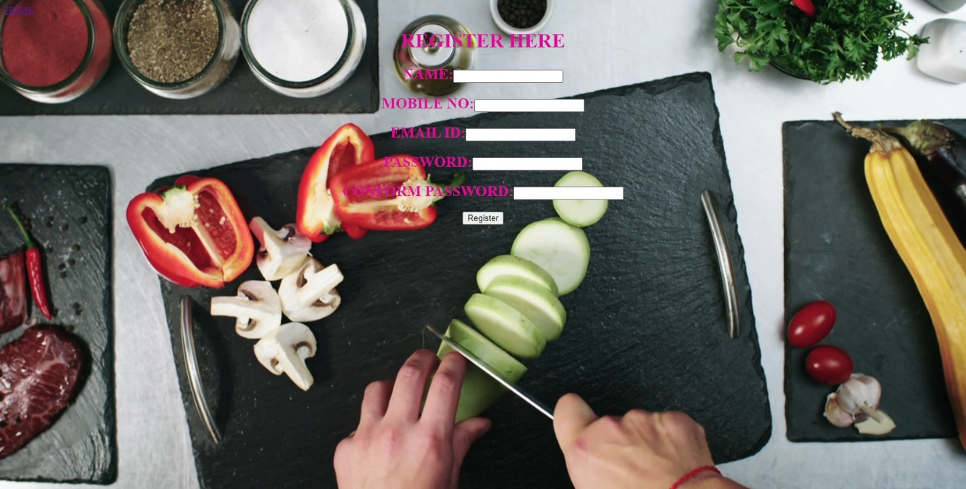

**SCREENSHOT(REGISTRATION PAGE)**

**SCREENSHOT(LOGIN PAGE)**

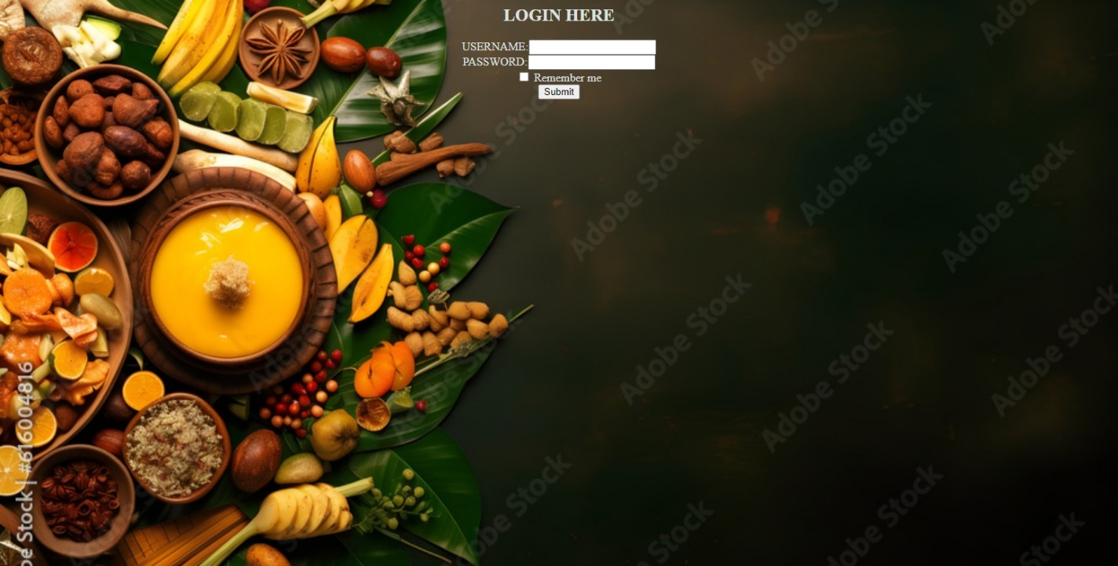

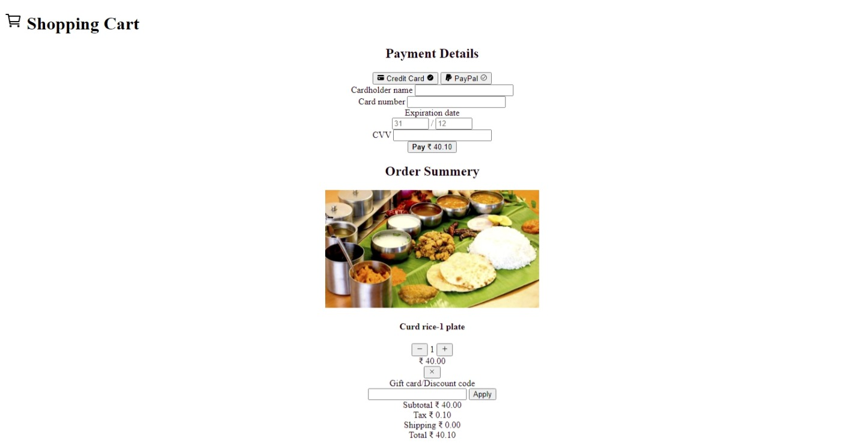

**SCREENSHOT(SHOPPING CART)**

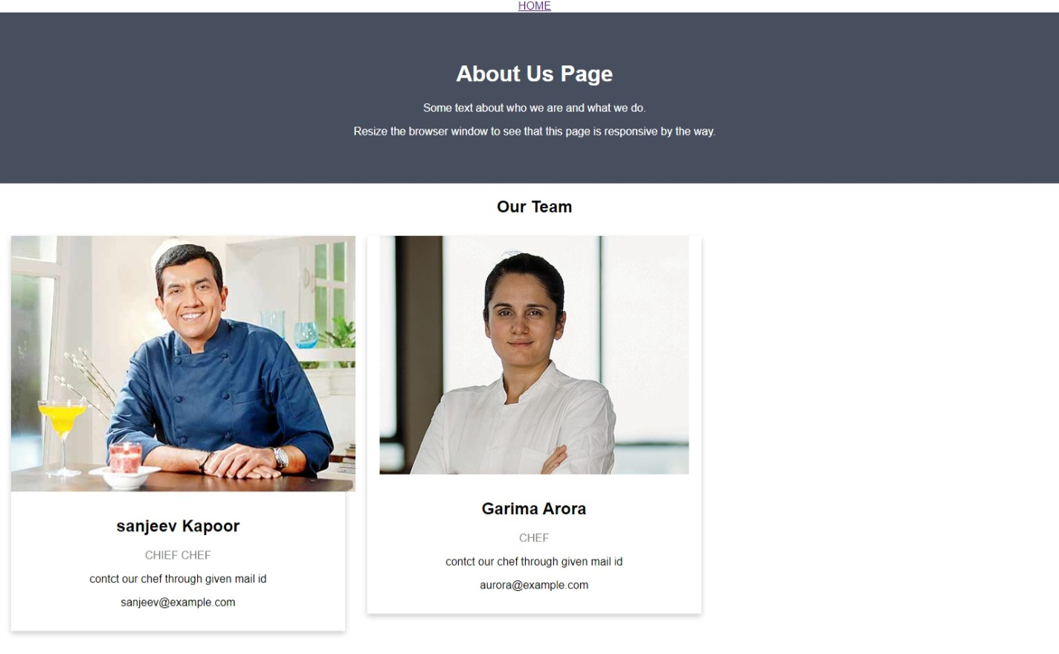

**SCREENSHOT(ABOUT US)**

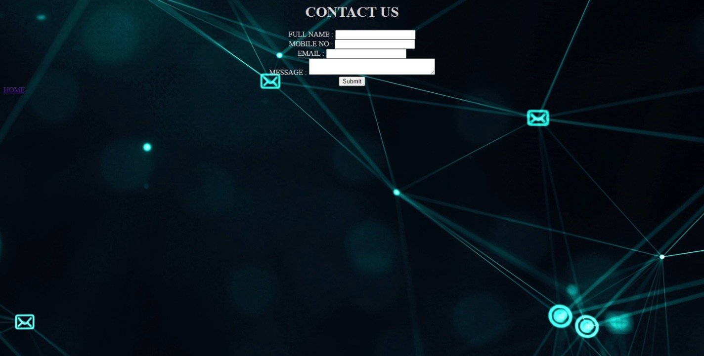

**SCREENSHOT(CONTACT US)**

**SCREENSHOT(MENU)**

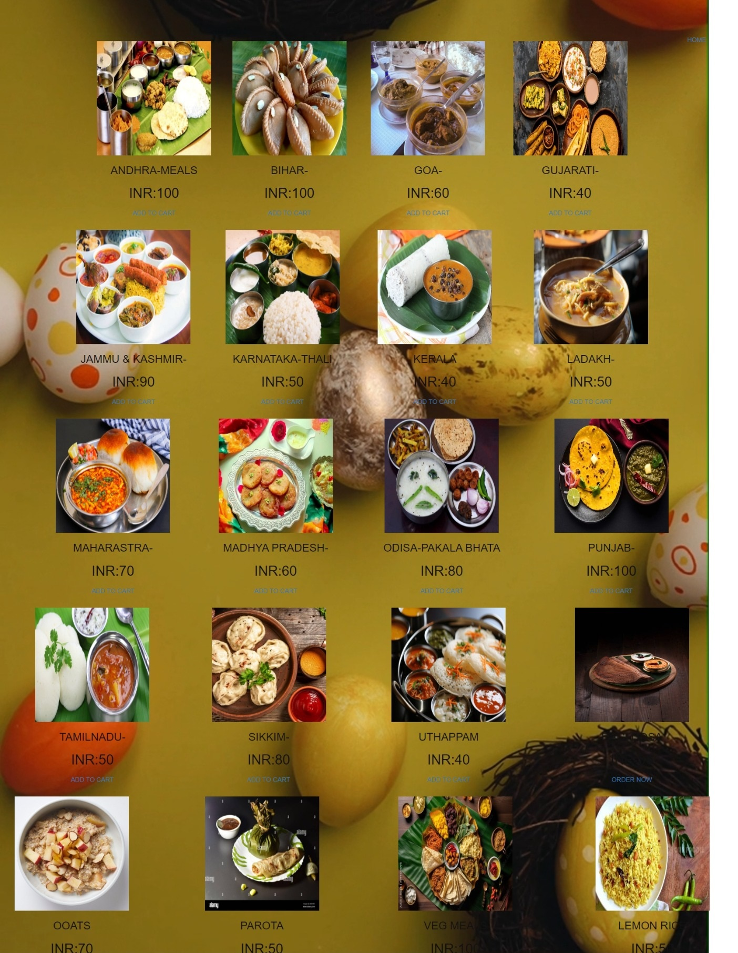

5.CONCLUSION

Our restaurant website is like a yummy menu book that you can look at online. You can see all the delicious food we make, from starters to desserts. You can even book a table to come and eat with us or order food to take away if you're too busy to visit. We also share fun things happening at our restaurant, like special events and deals.

Our website is easy to use, with big pictures of our food that make you hungry just by looking at them! You can use it on your phone, tablet, or computer, so you can check it out wherever you are.

We made our website with love, just like we make our food. We hope it makes you excited to come and dine with us and share your thoughts about our tasty treats.

**6.FUTURE WORK**

* **More Yummy Pictures:** We'll add more mouthwatering images of our dishes to tempt your taste buds even more.
* **Easy Online Ordering:** We'll make it even simpler for you to order food online, with options for customization and special requests.
* **Exciting Events:** Look forward to more fun events and promotions, like themed nights and exclusive discounts, shared right on our website.
* **Community Corner:** We'll create a space for you to share your experiences and interact with other food lovers, making our website feel like a cozy dining community.
* **Mobile App:** Stay tuned for the launch of our mobile app, making it even easier for you to browse our menu, place orders, and receive updates on the go.
* **Special Dietary Options:** We'll expand our website to include more information about dietary options, including vegan, gluten-free, and allergen-friendly dishes.
* **Virtual Cooking Classes:** Get ready to learn some of our chef's secrets with virtual cooking classes that you can join right from our website.
* **Enhanced Reservation System:** We'll improve our reservation system to offer more flexibility and options for booking your table, ensuring a seamless experience from start to finish.
* **Feedback Hub:** We'll create a dedicated space for you to share your feedback and suggestions, helping us continuously improve and tailor our offerings to your preferences.
* **Sustainability Initiatives:** Learn about our efforts to become more sustainable and environmentally friendly, including initiatives like reducing food waste and supporting local farmers.